

*Bachelor of Science in Computer Science (2016-2020)*

**Software Requirement Specifications Document**

*For:*

**Atom**

**Brain-Computer Interfacing using Electroencephalography**

*Supervisor:*

**Dr. Yasir Faheem**

*Submitted by:*

|  |  |
| --- | --- |
| **Muhammad Faizan Badar** | **CU / FA16-BCS-054 / ISB** |
| **Kinza Arshad** | **CU / FA16-BCS-108 / ISB** |

*Submission Date:* 4th October, 2019

Version 1.0

**COMSATS University Islamabad,  
Park Road, Chak Shahzad, Islamabad, Pakistan**

Department of Computer Science

|  |  |  |
| --- | --- | --- |
| **No.** | **Comment** | **Action** |
|  |  |  |
|  |  |  |
|  |  |  |
|  |  |  |
|  |  |  |
|  |  |  |

**SRS DOCUMENT REVSION HISTORY**

**Supervisor Signature**

**Date:**

**TABLE OF CONTENTS**

Introduction 1

Purpose 1

Scope 2

Overall Description 2

Product Perspective 3

Operating Environment 3

Design and Implementation Constraints 3

Requirement Identification 4

Use cases 4

Diagrams 4

Descriptions 10

Functional Requirements 64

Non-Functional Requirements 88

# Introduction

Our project deals with the domain of Brain-Computer interface and Cognitive Electrophysiology. As the name suggests it uses brain to give input and reads its input by tapping into the electric mode pf communication that our neuron use to communicate all the thoughts and functionalities, we are able to perform. The field is growing, and the possibilities are endless. The fundamental idea is to use this EEG incorporated BCI to target issues relating to human activities, specifically enhancing the attention span to improve focus in daily activities such as reading and others with similar brain involvement. The methodology we’ve chosen to achieve said claim can be divided into two streams; entertainment incentivized training and specialized controlled training, achieved by mini-games and a book reader respectively, where-in both these utilities are taken use of by the BCI to be built

This document will specify the hardware and the software aspects while also discussing the compatibility of different platforms and the integration of different modules that come together to make the whole project.

## Purpose

This document is being made available so that everyone can get an idea what we are trying to achieve and the benefits of this product. To dive into the technical problems and how we are solving some of the hurdles to deliver this project. The main goal really is to improve the mental health of the general public and making them more productive and focused.

Making the world a better place one problem at a time. The issue we have chosen to raise is millennialism and the increasing patients of ADHD in the future generations. For single human being scrolling through their virtual-self on social networks and getting entertained, in the background, the sense of pride and happier mood is because of the drug dopamine which for many complex anatomical reasons and signs implies happiness, comfort and pleasure in general. To keep a dopamine cycle going, the “scrolling” or the “scrubbing” takes up most of the social networking quota allocated per hour for every individual. On the other hand, whilst reading to a book or focusing on a task which in effect releases this sweet pleasured drug, the user desserts the activity entirely. This in nutshell deductively follows to the conclusion that it’ll lead to a population whose daily completion of any set of tasks relies on self-appraisal and dopamine cycles.

To remove this plague, it is necessary to take action and improve our health and keep our mind from wandering to focus more on productive things. Our application equips u with just what u need to beat this problem. Social media apps have engulfed our generation keeping us hooked on them so much that we can’t survive without them. As the world grew the need to become fast-paced and constantly connected felt important but it is also important sometimes to sit back, take a breath and see life in a new perspective to yield better results and to make new discoveries. The notification bell from our mobile apps keeps us on our toes depriving us of the pleasure to really enjoy a book. Our intention with this project is to tap into your brain and slowly divert u away from the toxic habits that rule your brain.

## Scope

So, in nutshell, our system is a BCI that detects the mental state of the user while he or she is using the provided utilities e.g. the reading exercise and the mini-games, from the detected mental state makes the prediction with some confidence that whether the user is paying attention or has lost focus. The BCI will achieve this using the hardware provisions of an EEG system, a headset, to gather brain wave readings and judge the state by using pre-programmed experience and a learnt model from previous examples. EEG defines its readings to be of five types of waves; namely the following:

1- Alpha: graphing the occipital lobe’s specifics regarding the visual stimuli,

2- Beta: graphing the fontal lobe’s specifics regarding the conscious thought and movement,

3- Theta: graphing sleep pertinent specifics and apparent in children,

4- Delta: partially sleep relevant specifics, while apparent in infants,

5- and Gamma: highest frequency waves ending spectral range,

and if a specific part or cortex of the human brain is targeted, depending on the requirement and the nature of the part of brain, then while performing the activity any change in the mental state can be detected by different fluctuations in all these different types of waves. The command center is located in the frontal lobe which is also responsible for the conscious thought and voluntary movement. Although targeting one cortex limits us from the other aspects of the mental state detection such as emotion recognition, social involvement, the human vision. This also limits the overall accuracy due to lower spatial averaging, upon which the entire system is based.

# Overall Description

To achieve self-awareness, the above proposed BCI can be used to make any user of the complementary application aware of the fact that he or she has lost focus during the indulgence of this certain task. Technically, this will be achieved by identification of a pattern difference in the Electroencephalograph of the user, which our system will learn by gathering experience and learning from previous examples to build and develop. A state in which the user has lost the focus, reinforcement of attention can be achieved in a multitude of ways.

* We lose our focus doing certain tasks, so if there’s monitor and check on this, we can bring forth a targeted solution
* Amongst all the victims of this mind wandering dilemma, the task of book reading is the most popular one. Almost all readers face this problem, and we can design our system to monitor our users and train them to pay more attention to this task at hand
* For the other population, which did not even get into reading, a more suitable way is to use entertainment in form games.

## Product Perspective

The idea of this project started out as a focus reinforcement tool. There have been examples where the same technology has been used to help meditate, play games and for medical purposes to detect seizures, sleep studies etc. The thing that makes this project unique is that this technology has not been used to get rid of ADHD and games have never been focused to train the brain like we are doing. So, it can be said that over project encompasses all of the previous uses of this technology, incorporates them in such a way that it improves productivity and increases mental health like it’s never been done before.

## Operating Environment

The software will operate on android platform. All the data of users will be held at a database and everyone who has the application in their mobile will be able to access data they have clearance to access, play games and upload their results.

## Design and Implementation Constraints

* Python: python will be used as a programming language because most of machine learning libraries are in python e.g. keras , TensorFlow etc. .
* Unity: unity is well reputed for game development and works well in coherence with python.
* Iron Python: to create a link between unity and python and run python scripts directly from c# scripts in unity
* Android: mobile app is chosen for the ease of access and as mobile users are more, we can target a bigger percentage of the population.
* Emotive headset: provides better accuracy and wireless headset is easy to use. Also, they are recommended by others in field to be the best out of all the options.

# Requirement Identification

## Use cases

### Diagrams

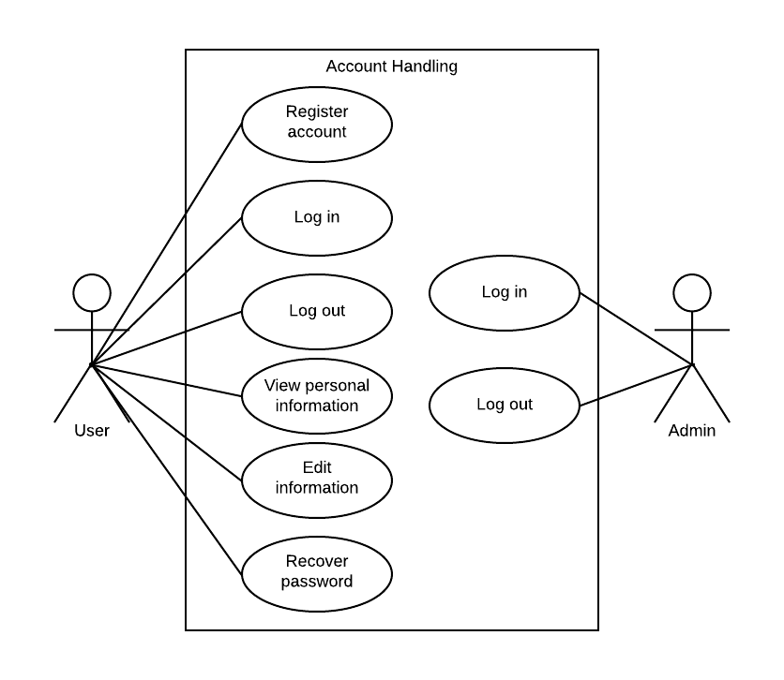

Figure Use case diagram for Account Handling module

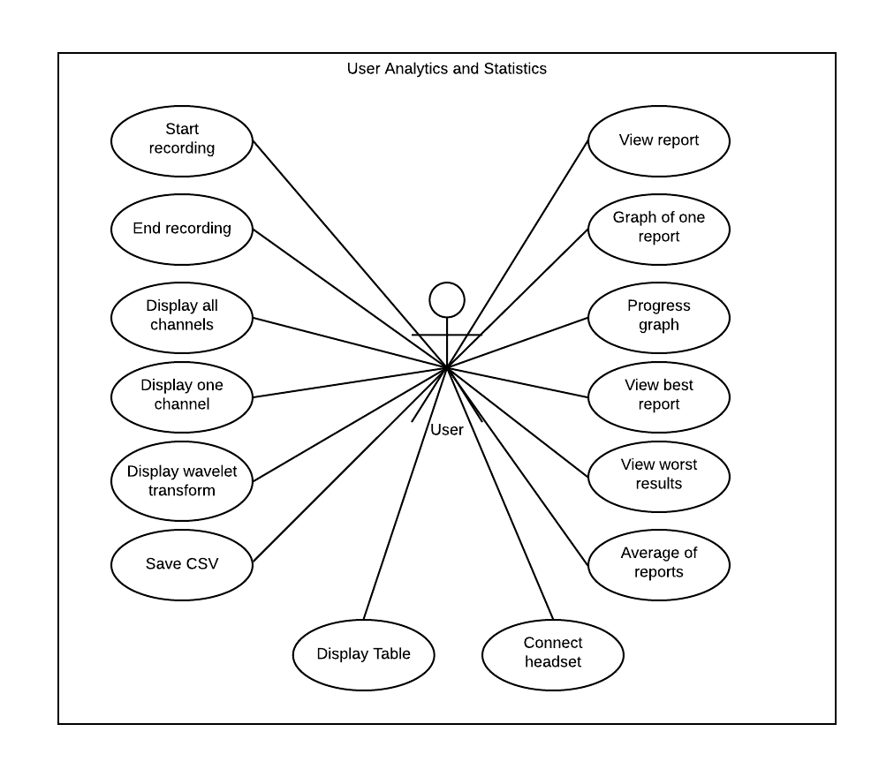

Figure Use case diagram for User Analytics and Statistics

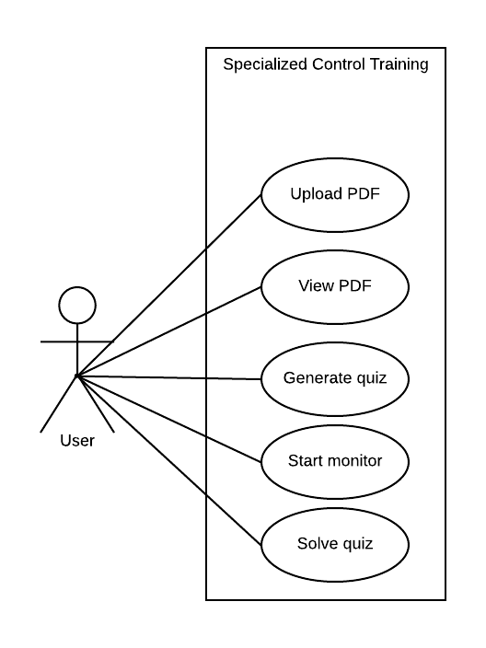

Figure Use case diagram for Specialized Control Training

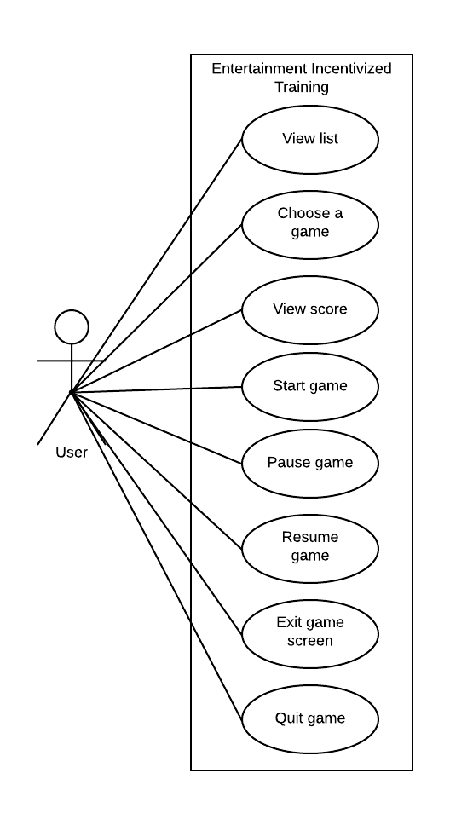

Figure Use case diagram for Entertainment Incentivized Training

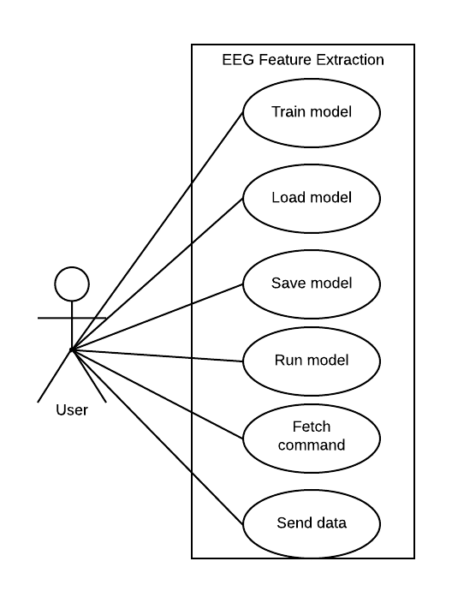

Figure Use case diagram for EEG Feature Extraction

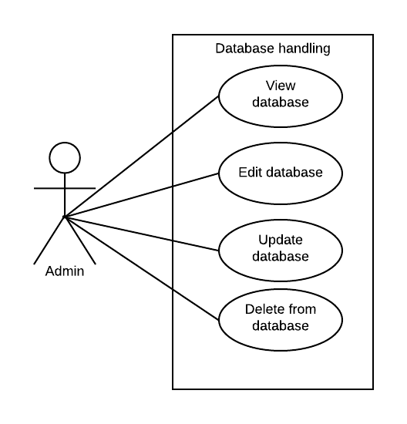

Figure Use case diagram for Database Handling

### Descriptions

|  |  |
| --- | --- |
| **Module** | **Usecases** |

|  |  |
| --- | --- |
| Account Handling | 1. Register account 2. Log in 3. Log out 4. View personal information 5. Edit information 6. Recover password 7. Password check 8. Log in (Admin) 9. Already exists check (Admin) |

|  |  |
| --- | --- |
| User Analytics and Statistics | 1. View report 2. Graph of one report 3. Progress graph 4. View best report 5. View worst result 6. Average of reports 7. Start recording 8. End recording 9. Display all channels 10. Display one channel 11. Display wavelet transform 12. Save CSV 13. Display table 14. Connect headset |

|  |  |
| --- | --- |
| Specialized Control Training | 1. Upload pdf 2. View pdf 3. Generate quiz 4. Start monitor 5. Solve quiz |

|  |  |
| --- | --- |
| Entertainment Incentivized Training | 1. View list 2. Choose a game 3. View score 4. Start game 5. Pause game 6. Resume game 7. Exit game screen 8. Quit game |

|  |  |
| --- | --- |
| EEG Feature Extraction | 1. Train model 2. Load model 3. Save model 4. Run model 5. Fetch command 6. Send data |

|  |  |
| --- | --- |
| Database Handling | 1. View database(admin) 2. Edit database(admin) 3. Update database(admin) 4. Delete from database(admin) |

#### Module 1: Account Handling

|  |  |
| --- | --- |
| Use Case ID: | UC-1 |
| Use Case Name: | Register Account |
| Actors | Primary actor : user |
| Description: | This registers the user account in the database so that all the data can be placed at one place regarding that user and to ensure privacy of users. |
| Trigger: | User/primary actor initiates this usecase to register his/her account. This use case will be triggered by a button on the first page at the bottom right which will take the user to a form containing empty fields to fill in their information |
| Preconditions: | As registration is one of the first tasks when the application loads so it doesn’t have preconditions other than the application data must be installed and a working internet connection should be provided. |
| Postconditions: | Success: In this case the account is registered and now user can start using the app and find all his data in his account.  Failure: In this case the account will not be registered am user will be notified. |
| Normal Flow: | * User has to enter his/her name * Enter user name * Enter password * Click sign-up * Wait for the confirmation notification |
| Alternative Flows: | N/A |
| Exceptions: | * Internet connection unstable * Username exists * Database connection failed |
| Business Rules | N/A |
| Assumptions: | * Account does not already exist |

|  |  |
| --- | --- |
| Use Case ID: | UC-2 |
| Use Case Name: | Log-in |
| Actors | Primary actor : user |
| Description: | This logs-in the user account , fetches the account data from the database which can be viewed and edited |
| Trigger: | User/primary actor initiates this usecase to log-in his/her previously registered account. This use case will be triggered by a button on the first page at the center which will take the user to a form containing empty fields to fill in their username and password. |
| Preconditions: | * Registered account * Stable Internet connection * Database connection |
| Postconditions: | Success: In this case the account is logged-in and now user can start using the app.  Failure: In this case the account will not log-in and the user will be notified. |
| Normal Flow: | * User has to enter his/her name * Enter user name * Enter password * Click sign-in * Wait for the confirmation notification |
| Alternative Flows: | N/A |
| Exceptions: | * Unstable internet connection * Username wrong * Password wrong * Database connection failed |
| Business Rules | N/A |
| Assumptions: | * Account is registered in the database * Password provided against the username is correct |

|  |  |
| --- | --- |
| Use Case ID: | UC-3 |
| Use Case Name: | Log-out |
| Actors | Primary actor : user |
| Description: | This logs-out the user account so it cannot be accessed by someone else . |
| Trigger: | User/primary actor initiates this usecase to log-out his/her previously logged-in account. This use case will be triggered by a button on the home page at the top right corner which will take the user back to the log-in page. |
| Preconditions: | * Logged-in account * Stable Internet connection |
| Postconditions: | Success: in this case the account will be logged-out  Failure: In this case the account will not be logged-out and the user will be notified. |
| Normal Flow: | * User has to click on the profile picture on the top right * Click then button sign-out * Wait for the confirmation notification |
| Alternative Flows: | * Click settings * Click log-out at the bottom of the drop-down menu |
| Exceptions: | * Internet connection unstable |
| Business Rules | N/A |
| Assumptions: | * Account signed-in |

|  |  |
| --- | --- |
| Use Case ID: | UC-4 |
| Use Case Name: | View personal information |
| Actors | Primary actor : user |
| Description: | This opens the settings page which has all the information the user entered about themselves e.g profile picture, name etc |
| Trigger: | User/primary actor initiates this usecase to view his/her previously entered information . This use case will be triggered by a button on the home page which will take the user to the settings page. |
| Preconditions: | * Logged-in account * Stable Internet connection |
| Postconditions: | Success: In this case the information is displayed on the settings page .  Failure: In this case the settings page will not open and user will be notified. |
| Normal Flow: | * Log-in account * Click on profile pic at the top right * Click on view timeline |
| Alternative Flows: | * Click settings * Click about me in the drop-down menu |
| Exceptions: | * Internet connection unstable |
| Business Rules | N/A |
| Assumptions: | * Account information was entered when account was registered |

|  |  |
| --- | --- |
| Use Case ID: | UC-5 |
| Use Case Name: | Edit information |
| Actors | Primary actor : user |
| Description: | This opens a small window with input fields to edit the previous information |
| Trigger: | User/primary actor initiates this usecase to edit his/her previously given information . This use case will be triggered by a button on the settings page which will take the user to a small window from where he can change his personal information |
| Preconditions: | * Logged-in account * Stable Internet connection |
| Postconditions: | Success: In this case the information is edited  Failure: In this case the information will not be edited and user will be notified. |
| Normal Flow: | * Log-in account * Click profile pic * Click view timeline * Click button edit beside the information that needs to be edited e.g. name etc. * Enter new information * Click done * Wait for notification for confirmation |
| Alternative Flows: | * Log-in account * Open settings * Click about me * Click button edit beside the information that needs to be edited e.g. name etc. * Enter new information * Click done * Wait for notification for confirmation |
| Exceptions: | * Internet connection unstable * Database connection failed |
| Business Rules | N/A |
| Assumptions: | * Account logged-in |

|  |  |
| --- | --- |
| Use Case ID: | UC-6 |
| Use Case Name: | Recover password |
| Actors | Primary actor : user |
| Description: | This opens the recover password page and asks the user if they wan to reset the password. |
| Trigger: | User/primary actor initiates this usecase to reset his/her password. This use case will be triggered by a button on the log-in page which will take the user to the recover password page from where he can reset the password which will be sent to the recovery email . |
| Preconditions: | * Stable Internet connection |
| Postconditions: | Success: In this case the password is reset and sent to the recovery email.  Failure: In this case the password will not reset |
| Normal Flow: | * Click forgot password button * Get the new password from recovery email * Sign-in with new password |
| Alternative Flows: | N/A |
| Exceptions: | * Internet connection unstable * Account not registered * Recovery email not found |
| Business Rules | N/A |
| Assumptions: | * Account registered * Recovery email provided * Recovery email exists |

|  |  |
| --- | --- |
| Use Case ID: | UC-7 |
| Use Case Name: | Password-check |
| Actors | System triggers this usecase . |
| Description: | This checks if the password is correct then the user logs-in. |
| Trigger: | This is in initiated when the user logs-in. This use case will be triggered by the sign-in use case which will check the user-password . |
| Preconditions: | * Log-in * Stable Internet connection |
| Postconditions: | Success: password is right. Account is opened  Failure: In this case the password is wrong and generates a notification |
| Normal Flow: | * Enter email * Enter password * Click sign-in * Wait for confirmation notification |
| Alternative Flows: | N/A |
| Exceptions: | * Internet connection unstable * Password wrong |
| Business Rules | N/A |
| Assumptions: | * Account registered * Password correct |

|  |  |
| --- | --- |
| Use Case ID: | UC-8 |
| Use Case Name: | Log-in(admin) |
| Actors | Primary actor : user |
| Description: | This usecase starts when email and password are entered to log in to the admin account. |
| Trigger: | admin actor initiates this usecase to open their account. This use case will be triggered by a button log-In. |
| Preconditions: | * Stable Internet connection * Headset connected * Registered account * Database connection |
| Postconditions: | Success: In this case the account opens and the admin can start using it.  Failure: In this case the monitor will not start. |
| Normal Flow: | * Enter name * Enter password * Click sign-in |
| Alternative Flows: | N/A |
| Exceptions: | * Unstable internet connection * Account not registered * Database connection failed * Password doesn’t match |
| Business Rules | N/A |
| Assumptions: | * Account registered |

|  |  |
| --- | --- |
| Use Case ID: | UC-9 |
| Use Case Name: | Already-exists-check(admin) |
| Actors | System |
| Description: | This usecase starts when email and password are entered to sign-up . |
| Trigger: | System initiates this usecase to check if the username exists or not . This use case will be triggered by a button log-In. |
| Preconditions: | * Stable Internet connection * Database connection |
| Postconditions: | Success: In this case the account is registered  Failure: In this case the account will not be registered and a notification will be generated |
| Normal Flow: | * Enter name * Enter password * Click sign-in |
| Alternative Flows: | N/A |
| Exceptions: | * Unstable internet connection * Username already exists * Database connection failed |
| Business Rules | N/A |
| Assumptions: | * Username does not already exist |

#### Module 2: User Analytics and Statistics

|  |  |
| --- | --- |
| Use Case ID: | UC-10 |
| Use Case Name: | View-report |
| Actors | Primary actor : user |
| Description: | This opens the weekly progress reports generated of the user |
| Trigger: | User/primary actor initiates this usecase to view his/her previously generated reports. This use case will be triggered by a button on the home page which will take the user to the reports page from where he can choose from a lost of reports |
| Preconditions: | * Logged-in account * Stable Internet connection * Reports present to view |
| Postconditions: | Success: In this case the chosen report is displayed.  Failure: In this case the report will not open |
| Normal Flow: | * Log-in account * Play a game or do the reading activity * Open user-analytics tab * Choose a report * Click button view report |
| Alternative Flows: | * Log-in account * Open user-analytics tab * Choose a report * Click button view report |
| Exceptions: | * Internet connection unstable * Report deleted from the database * Database connection failed |
| Business Rules | N/A |
| Assumptions: | * Account logged-in * Reports previously generated and saved |

|  |  |
| --- | --- |
| Use Case ID: | UC-11 |
| Use Case Name: | Graph of one report |
| Actors | Primary actor : user |
| Description: | This usecase displays the graph of one week result. |
| Trigger: | User/primary actor initiates this usecase to view his/her previously generated reports in the form of graph. |
| Preconditions: | * Logged-in account * Stable Internet connection * Previously generated reports |
| Postconditions: | Success: In this case the chosen report is displayed in graphical form  Failure: In this case the report will not open. |
| Normal Flow: | * Log-in account * Play a game or do the reading activity * Open user-analytics tab * Choose a report * Click button view report * Click the graph tab at the bottom of the screen * Wait for confirmation notification. |
| Alternative Flows: | N/A |
| Exceptions: | * Internet connection unstable * Database connection failure * Report deleted from the database |
| Business Rules | N/A |
| Assumptions: | * Logged-in account * Reports previously generated to view |

|  |  |
| --- | --- |
| Use Case ID: | UC-12 |
| Use Case Name: | Progress graph |
| Actors | Primary actor : user |
| Description: | This opens the graph of all the previous reports to shoe the progress. |
| Trigger: | User/primary actor initiates this usecase to view his/her progress over the time . This use case will be triggered by a button on the home page which will take the user to the reports page and display the progress report. |
| Preconditions: | * Logged-in account * Stable Internet connection * Previously generated reports. |
| Postconditions: | Success: In this case the progress report is displayed.  Failure: In this case the report will not open. |
| Normal Flow: | * Log-in account * Play a game or do the reading activity * Open user-analytics tab * Click button progress report * Wait for confirmation notification. |
| Alternative Flows: | N/A |
| Exceptions: | * Internet connection unstable * Report deleted from the database * No reports present to display the progress report * Database connection failed |
| Business Rules | N/A |
| Assumptions: | * Logged-in account * Previously generated reports |

|  |  |
| --- | --- |
| Use Case ID: | UC-13 |
| Use Case Name: | View best report |
| Actors | Primary actor : user |
| Description: | This finds the best report out of all present reports and displays that in table format. |
| Trigger: | User/primary actor initiates this usecase to view his/her best out of previously generated reports. This use case will be triggered by a button on the home page which will take the user to the best report in tabular form. |
| Preconditions: | * Logged-in account * Stable Internet connection * Previously generated reports |
| Postconditions: | Success: In this case the best report is displayed.  Failure: In this case the report will not open. |
| Normal Flow: | * Log-in account * Play a game or do the reading activity * Open user-analytics tab * Click button view best report * Wait for confirmation notification. |
| Alternative Flows: | N/A |
| Exceptions: | * Internet connection unstable * No reports present * Database connection failed |
| Business Rules | N/A |
| Assumptions: | * Logged-in account * Previously generated reports |

|  |  |
| --- | --- |
| Use Case ID: | UC-14 |
| Use Case Name: | View worst result |
| Actors | Primary actor : user |
| Description: | This opens the worst result out of all the previously generated reports |
| Trigger: | User/primary actor initiates this usecase to view his/her previously generated worst report. This use case will be triggered by a button on the home page which will take the user to the reports page from where he will press the worst report button. |
| Preconditions: | * Logged-in account * Stable Internet connection * Previously generated reports |
| Postconditions: | Success: In this case the worst report is displayed.  Failure: In this case the report will not open |
| Normal Flow: | * Log-in account * Play a game or do the reading activity * Open user-analytics tab * Click button view worst report * Wait for confirmation notification. |
| Alternative Flows: | N/A |
| Exceptions: | * Internet connection unstable * No reports present * Database connection failed |
| Business Rules | N/A |
| Assumptions: | * Account logged-in * Reports previously generated |

|  |  |
| --- | --- |
| Use Case ID: | UC-15 |
| Use Case Name: | Average of reports |
| Actors | Primary actor : user |
| Description: | This opens the average of weekly reports generated of the user |
| Trigger: | User/primary actor initiates this usecase to view his/her average of all the previously generated reports. This use case will be triggered by a button on the home page which will take the user to the reports page from where he will press the average of reports button |
| Preconditions: | * Logged-in account * Stable Internet connection * Previously generated reports |
| Postconditions: | Success: In this case the average of previously generated reports is displayed.  Failure: In this case the report will not open and user will be notified. |
| Normal Flow: | * Log-in account * Play a game or do the reading activity * Open user-analytics tab * Click button view worst report * Wait for confirmation notification. |
| Alternative Flows: | N/A |
| Exceptions: | * Internet connection unstable * No reports present * Database connection failed |
| Business Rules | N/A |
| Assumptions: | * Account logged-in * Reports previously generated |

|  |  |
| --- | --- |
| Use Case ID: | UC-16 |
| Use Case Name: | Start recording |
| Actors | Primary actor : user |
| Description: | This usecase starts when the button record is pressed from recording page . |
| Trigger: | User/primary actor initiates this usecase to record his/her brainwaves in the csv format . This use case will be triggered by a button record on the recording page. |
| Preconditions: | * Logged-in account * Stable Internet connection * Headset integration page opened * Headset connected |
| Postconditions: | Success:  Failure: |
| Normal Flow: | * Log-in account * Click button record on the home page * Click start recording on recording-page |
| Alternative Flows: | N/A |
| Exceptions: | * Internet connection unstable * Headset not connected |
| Business Rules | N/A |
| Assumptions: | * Account logged-in * Recording page opened |

|  |  |
| --- | --- |
| Use Case ID: | UC-17 |
| Use Case Name: | End recording |
| Actors | Primary actor : user |
| Description: | This usecase starts when the button end is pressed from headset integration page is |
| Trigger: | User/primary actor initiates this usecase to stop recording his/her brainwaves. This use case will be triggered by a button end on the headset integration page. |
| Preconditions: | * Logged-in account * Stable Internet connection * Headset integration page opened * Headset connected |
| Postconditions: | Success: In this case the brainwaves will stop recording  Failure: In this case the brainwaves will not stop recording. |
| Normal Flow: | * Log-in account * Click button record on the home page * Click start recording on recording-page * Click on end recording |
| Alternative Flows: | N/A |
| Exceptions: | * Internet connection unstable * Headset not connected |
| Business Rules | N/A |
| Assumptions: | * Account logged-in * Recording page opened * Recording started |

|  |  |
| --- | --- |
| Use Case ID: | UC-18 |
| Use Case Name: | Display all channels |
| Actors | Primary actor : user |
| Description: | This usecase starts when the button display channels is pressed from headset integration page. |
| Trigger: | User/primary actor initiates this usecase to view his/her brainwaves in the raw form. This use case will be triggered by a button display all channels on the headset integration page |
| Preconditions: | * Logged-in account * Stable Internet connection * Headset integration page opened * Headset connected * Previous recordings present |
| Postconditions: | Success: In this case the brainwaves will be displayed in the raw form  Failure: In this case the the brainwaves will not be displayed |
| Normal Flow: | * Log-in account * Choose a previous report * Click on display all channels |
| Alternative Flows: | N/A |
| Exceptions: | * Internet connection unstable * Headset not connected * Previous reports not present |
| Business Rules | N/A |
| Assumptions: | * Account logged-in * Recording page opened * Reports present to display |

|  |  |
| --- | --- |
| Use Case ID: | UC-19 |
| Use Case Name: | Display one channel |
| Actors | Primary actor : user |
| Description: | This usecase starts when the button display channel is pressed from headset integration page. |
| Trigger: | User/primary actor initiates this usecase to view his/her brainwaves in the raw form from one channel. This use case will be triggered by a button present under all channels on the headset integration page. |
| Preconditions: | * Logged-in account * Stable Internet connection * Headset integration page opened * Headset connected |
| Postconditions: | Success: In this case the brainwaves will be displayed in the raw form. From the single channel that the user chose  Failure: In this case the the brainwaves will not be displayed |
| Normal Flow: | * Log-in account * Choose a report * Click display one channel |
| Alternative Flows: | N/A |
| Exceptions: | * Internet connection unstable * Headset not connected * No reports present to display |
| Business Rules | N/A |
| Assumptions: | * Account logged-in * Recording page opened * Reports present |

|  |  |
| --- | --- |
| Use Case ID: | UC-20 |
| Use Case Name: | Display wavelet transform |
| Actors | Primary actor : user |
| Description: | This usecase starts when the button wavelet-transform is pressed from headset integration page |
| Trigger: | User/primary actor initiates this usecase to view his/her brainwaves after the application of wavelet transform on them. This use case will be triggered by a button present under each channel on the headset integration page. |
| Preconditions: | * Logged-in account * Stable Internet connection * Headset integration page opened * Headset connected |
| Postconditions: | Success: In this case the brainwaves will be displayed in the wavelet transform form.  Failure: In this case the the brainwaves will not be displayed |
| Normal Flow: | * Log-in account * Choose report * Click on wavelet transform |
| Alternative Flows: | N/A |
| Exceptions: | * Internet connection unstable * Headset not connected * No reports present to display |
| Business Rules | N/A |
| Assumptions: | * Account logged-in * Recording page opened * Reports present |

|  |  |
| --- | --- |
| Use Case ID: | UC-21 |
| Use Case Name: | Save csv |
| Actors | Primary actor : user |
| Description: | This usecase starts when the button save is pressed from headset integration page |
| Trigger: | User/primary actor initiates this usecase to save his/her brainwaves in the table/csv form. This use case will be triggered by a button save on the headset integration page. |
| Preconditions: | * Logged-in account * Stable Internet connection * Headset integration page opened * Headset connected |
| Postconditions: | Success: In this case the brainwaves will be saved in the table form  Failure: In this case the the brainwaves will not be saved |
| Normal Flow: | * Log-in account * Click button record on the home page * Click start recording on recording-page * Click on end recording * Click on save |
| Alternative Flows: | N/A |
| Exceptions: | * Internet connection unstable * Headset not connected |
| Business Rules | N/A |
| Assumptions: | * Account logged-in * Recording page opened |

|  |  |
| --- | --- |
| Use Case ID: | UC-22 |
| Use Case Name: | Display table |
| Actors | Primary actor : user |
| Description: | This usecase starts when the button display table is pressed from headset integration page. |
| Trigger: | User/primary actor initiates this usecase to view his/her brainwaves in the table form. This use case will be triggered by a button display table on the headset integration page. |
| Preconditions: | * Logged-in account * Stable Internet connection * Headset integration page opened * Headset connected |
| Postconditions: | Success: In this case the brainwaves will be displayed in the table form  Failure: In this case the the brainwaves will not be displayed |
| Normal Flow: | * Log-in account * Choose report * Click display table |
| Alternative Flows: | N/A |
| Exceptions: | * Internet connection unstable * Headset not connected * No reports present |
| Business Rules | N/A |
| Assumptions: | * Account logged-in * Recording page opened * Reports present |

|  |  |
| --- | --- |
| Use Case ID: | UC-23 |
| Use Case Name: | Connect headset |
| Actors | Primary actor : user |
| Description: | This usecase starts when the button connect is pressed from the focus re-enforcement page |
| Trigger: | User/primary actor initiates this usecase to connect the headset. This use case will be triggered by a button connect on the focus reinforcement page . |
| Preconditions: | * Logged-in account * Stable Internet connection * Focus re-enforcement page opened |
| Postconditions: | Success: In this case the book headset will be connected.  Failure: In this case the headset will not be connected. |
| Normal Flow: | * Log-in account * Open user-analytics page * Click connect headset |
| Alternative Flows: | N/A |
| Exceptions: | * Internet connection unstable * Headset not in range * Headset not charged |
| Business Rules | N/A |
| Assumptions: | * Account logged-in * Reading exercise page opened * Pdf’s present to read |

#### Module 3: Specialized Control Training

|  |  |
| --- | --- |
| Use Case ID: | UC-24 |
| Use Case Name: | Upload pdf |
| Actors | Primary actor : user |
| Description: | This usecase starts when the button upload is pressed. |
| Trigger: | User/primary actor initiates this usecase to upload a book . This use case will be triggered by a button upload on the focus reinforcement page . |
| Preconditions: | * Logged-in account * Stable Internet connection * Headset connected * Focus re-enforcement page opened |
| Postconditions: | Success: In this case the book chosen will be uploaded.  Failure: In this case the book will not be uploaded. |
| Normal Flow: | * Log-in account * Choose reading exercise button * Click on upload button * Choose a pdf * Click open |
| Alternative Flows: | N/A |
| Exceptions: | * Internet connection unstable * Headset not connected * No books present |
| Business Rules | N/A |
| Assumptions: | * Account logged-in * Reading exercise page opened * Pdf’s present to read |

|  |  |
| --- | --- |
| Use Case ID: | UC-25 |
| Use Case Name: | View pdf |
| Actors | Primary actor : user |
| Description: | This usecase starts when the button view is pressed on the focus re-enforcement page |
| Trigger: | User/primary actor initiates this usecase to view the pdf he uploaded. This use case will be triggered by a button view on the focus reinforcement page .to view the pdf |
| Preconditions: | * Logged-in account * Stable Internet connection * Headset connected * Focus re-enforcement page opened |
| Postconditions: | Success: In this case the book chosen will be displayed  Failure: In this case the book will not be displayed |
| Normal Flow: | * Log-in account * Choose reading exercise button * Click on upload button * Choose a pdf * Click open * Choose one pdf from uploaded pdf * Click view |
| Alternative Flows: | N/A |
| Exceptions: | * Internet connection unstable * Headset not connected * No books present |
| Business Rules | N/A |
| Assumptions: | * Account logged-in * Reading exercise page opened * Pdf’s present to read |

|  |  |
| --- | --- |
| Use Case ID: | UC-26 |
| Use Case Name: | Generate quiz |
| Actors | Primary actor : user |
| Description: | This usecase starts when the button take quiz is pressed and the system then generates a quiz from the pdf user was reading. |
| Trigger: | User/primary actor initiates this usecase to take a quiz. This use case will be triggered by a button take quiz on the focus reinforcement page |
| Preconditions: | * Logged-in account * Stable Internet connection * Headset connected * Focus re-enforcement page opened * Pdf opened |
| Postconditions: | Success: In this case a quiz will be generated.  Failure: In this case a quiz will be generated. |
| Normal Flow: | * Log-in account * Choose reading exercise button * Click on upload button * Choose a pdf * Click open * Click generate quiz |
| Alternative Flows: | This usecase can be started by the system when the focus level drops below threshold |
| Exceptions: | * Internet connection unstable * Headset not connected * No books present * Book not opened |
| Business Rules | N/A |
| Assumptions: | * Account logged-in * Reading exercise page opened * Pdf’s present to read * Book opened |

|  |  |
| --- | --- |
| Use Case ID: | UC-27 |
| Use Case Name: | Start monitor |
| Actors | Primary actor : user |
| Description: | This usecase starts when the button record is pressed from reading exercise page is |
| Trigger: | User/primary actor initiates this usecase to record his/her brainwaves in the csv format . This use case will be triggered by a button record on the reading exercise page. |
| Preconditions: | * Logged-in account * Stable Internet connection * Headset integration page opened * Headset connected |
| Postconditions: | Success: In this case the brainwaves will start recording  Failure: In this case the the brainwaves will not record |
| Normal Flow: | * Log-in account * Choose reading exercise button * Click on upload button * Choose a pdf * Click open * Click start monitor |
| Alternative Flows: | N/A |
| Exceptions: | * Internet connection unstable * Headset not connected * No books present |
| Business Rules | N/A |
| Assumptions: | * Account logged-in * Reading exercise page opened * Pdf’s present to read |

|  |  |
| --- | --- |
| Use Case ID: | UC-28 |
| Use Case Name: | Solve quiz |
| Actors | Primary actor : user |
| Description: | This usecase starts when the solve is pressed from the pop-up window that appears after generating the quiz |
| Trigger: | User/primary actor initiates this usecase to solve the generated quiz. This use case will be triggered by a button solve on the pop-up window. |
| Preconditions: | * Logged-in account * Stable Internet connection * Headset connected * Focus re-enforcement page opened * Uploaded pdf * Opened pdf * Generated quiz |
| Postconditions: | Success: In this case the generated quiz will be opened.  Failure: In this case the quiz will not be opened. |
| Normal Flow: | * Log-in account * Choose reading exercise button * Click on upload button * Choose a pdf * Click open * Click generate quiz * Click solve quiz |
| Alternative Flows: | Click solve quiz when prompted by the system to take quiz |
| Exceptions: | * Internet connection unstable * Headset not connected * No books present |
| Business Rules | N/A |
| Assumptions: | * Account logged-in * Reading exercise page opened * Pdf’s present to read |

#### Module 4: Entertainment Incentivized Training

|  |  |
| --- | --- |
| Use Case ID: | UC-29 |
| Use Case Name: | View list |
| Actors | Primary actor : user |
| Description: | This opens the list of games to choose from. |
| Trigger: | User/primary actor initiates this usecase to view the list o games to play. This use case will be triggered by a button on the game page where a list of all the games will be present . |
| Preconditions: | * Logged-in account * Stable Internet connection |
| Postconditions: | Success: In this case a list of all games is displayed  Failure: In this case the page will not load and following can be the cause |
| Normal Flow: | * Log-in account * Click button games on the home page |
| Alternative Flows: | N/A |
| Exceptions: | * Internet connection unstable |
| Business Rules | N/A |
| Assumptions: | * Logged-in account |

|  |  |
| --- | --- |
| Use Case ID: | UC-30 |
| Use Case Name: | Choose a game |
| Actors | Primary actor : user |
| Description: | This opens the chosen game and you can start playing. |
| Trigger: | User/primary actor initiates this usecase to play the game of his/her choice. This use case will be triggered by a play button on the game page under the game preview picture from the list of all the games on the game page. |
| Preconditions: | * Logged-in account * Stable Internet connection |
| Postconditions: | Success: In this case the game starts and user can start playing..  Failure: In this case the game will not load. |
| Normal Flow: | * Log-in account * Click button games on the home page * Choose a game |
| Alternative Flows: | N/A |
| Exceptions: | * Internet connection unstable |
| Business Rules | N/A |
| Assumptions: | * Log-in account |

|  |  |
| --- | --- |
| Use Case ID: | UC-31 |
| Use Case Name: | View score |
| Actors | Primary actor : user |
| Description: | This opens the score of the previous game . |
| Trigger: | User/primary actor initiates this usecase to view the score of previous game . This use case will be triggered by a button inside the game where score of previous game will be present. |
| Preconditions: | * Logged-in account * Stable Internet connection * Game played before to generate score |
| Postconditions: | Success: In this case the score of previous try will be displayed  Failure: In this case the score will not be displayed |
| Normal Flow: | * Log-in account * Click button games on the home page * Choose a game * Click view score on the game’s home page |
| Alternative Flows: | N/A |
| Exceptions: | * Internet connection unstable * No scores to view * Database connection failed |
| Business Rules | N/A |
| Assumptions: | * Logged-in account * Game’s home page opened * Scores of previous games present. |

|  |  |
| --- | --- |
| Use Case ID: | UC-32 |
| Use Case Name: | Start game |
| Actors | Primary actor : user |
| Description: | This usecase starts the game which was chosen. |
| Trigger: | User/primary actor initiates this usecase to play the game. This use case will be triggered by a button on the game menu . |
| Preconditions: | * Logged-in account * Stable Internet connection |
| Postconditions: | Success: In this case the game starts and you find yourself in the level .  Failure: In this case the level will not load. |
| Normal Flow: | * Log-in account * Click button games on the home page * Choose a game * Click view score on the game’s home page * Click start game button |
| Alternative Flows: | N/A |
| Exceptions: | * Internet connection unstable |
| Business Rules | N/A |
| Assumptions: | * Account logged-in * Game started |

|  |  |
| --- | --- |
| Use Case ID: | UC-33 |
| Use Case Name: | Pause game |
| Actors | Primary actor : user |
| Description: | This usecase starts when the button pause is pressed while the game is playing. |
| Trigger: | User/primary actor initiates this usecase to pause the game. This use case will be triggered by the button “pause” at the top right of the screen while the game is being played. |
| Preconditions: | * Logged-in account * Stable Internet connection * Game being played |
| Postconditions: | Success: In this case the game will pause in whatever state it is  Failure: In this case the level will not pause. |
| Normal Flow: | * Log-in account * Click button games on the home page * Choose a game * Click view score on the game’s home page * Click start game button * Click pause button |
| Alternative Flows: | N/A |
| Exceptions: | * Internet connection unstable |
| Business Rules | N/A |
| Assumptions: | * Account logged-in * Game started |

|  |  |
| --- | --- |
| Use Case ID: | UC-34 |
| Use Case Name: | Resume game |
| Actors | Primary actor : user |
| Description: | This usecase starts when the button “Resume” is pressed while the game is paused. |
| Trigger: | User/primary actor initiates this usecase to restart the game from the point he/she paused it. This use case will be triggered by a button “Resume” at the center of the page while the game is paused. |
| Preconditions: | * Logged-in account * Stable Internet connection * Game being played * Game paused state |
| Postconditions: | Success: In this case the game will resume in whatever state it was before being paused.  Failure: In this case the level will not resume from the paused state . |
| Normal Flow: | * Log-in account * Click button games on the home page * Choose a game * Click view score on the game’s home page * Click start game button * Click pause button * Click resume button |
| Alternative Flows: | N/A |
| Exceptions: | * Internet connection unstable |
| Business Rules | N/A |
| Assumptions: | * Account logged-in * Game started * Game paused |

|  |  |
| --- | --- |
| Use Case ID: | UC-35 |
| Use Case Name: | Exit game screen |
| Actors | Primary actor : user |
| Description: | This usecase starts when the button “back” is pressed while the game is playing. |
| Trigger: | User/primary actor initiates this usecase to EXIT the gamescreen. This use case will be triggered by a button “back” while the game is being played |
| Preconditions: | * Logged-in account * Stable Internet connection * Game being played |
| Postconditions: | Success: In this case the game will EXIT to the game menu in whatever state it is  Failure: In this case the gamescreen will not exit. |
| Normal Flow: | * Log-in account * Click button games on the home page * Choose a game * Click view score on the game’s home page * Click start game button * Click back button |
| Alternative Flows: | N/A |
| Exceptions: | * Internet connection unstable |
| Business Rules | N/A |
| Assumptions: | * Account logged-in * Game started |

|  |  |
| --- | --- |
| Use Case ID: | UC-36 |
| Use Case Name: | Quit game |
| Actors | Primary actor : user |
| Description: | This usecase starts when the button quit from the game menu is pressed. |
| Trigger: | User/primary actor initiates this usecase to quit the game and go back to the gamesList to choose another. This use case will be triggered by a button quit on the game menu. |
| Preconditions: | * Logged-in account * Stable Internet connection * Game menu opened |
| Postconditions: | Success: In this case the user will be taken back to the gamePage  Failure: In this case the gamePage will not be opened |
| Normal Flow: | * Log-in account * Click button games on the home page * Choose a game * Click quit button |
| Alternative Flows: | * Log-in account * Click button games on the home page * Choose a game * Click start game button * Click back button * Click quit button |
| Exceptions: | * Internet connection unstable |
| Business Rules | N/A |
| Assumptions: | * Account logged-in * Game started |

#### Module 5: EEG Feature Extraction

|  |  |
| --- | --- |
| Use Case ID: | UC-37 |
| Use Case Name: | Train model |
| Actors | System |
| Description: | This usecase starts this usecase to tarin the moel with the data recorded during the game by the user. |
| Trigger: | System initiates this usecase to train the model on the data provided by the user while the user is playing any game. It is triggered byt the place of user at a specific part of the game. |
| Preconditions: | * Logged-in account * Stable Internet connection * Game started |
| Postconditions: | Success: In this case the system will train the model successfully.  Failure: In this case the training process will somehow be interrupted. |
| Normal Flow: | * Log-in account * Click button games on the home page * Choose a game |
| Alternative Flows: | N/A |
| Exceptions: | * Internet connection unstable * Training process interrupted * Game not started |
| Business Rules | N/A |
| Assumptions: | * Account logged-in * Game started |

|  |  |
| --- | --- |
| Use Case ID: | UC-38 |
| Use Case Name: | Load model |
| Actors | System |
| Description: | This usecase starts this use case to load a pre-trained model to use . |
| Trigger: | System initiates this usecase to load a pre-trained model while the game is being played to classify the commands using the data sent by the user. This is triggered by the progression of game to a specific point . |
| Preconditions: | * Logged-in account * Stable Internet connection * Game started |
| Postconditions: | Success: In this case the system will load the model successfully.  Failure: In this case the loading process will somehow be interrupted. |
| Normal Flow: | * Log-in account * Click button games on the home page * Choose a game * Start game |
| Alternative Flows: | N/A |
| Exceptions: | * Internet connection unstable * Training process interrupted * Game not started |
| Business Rules | N/A |
| Assumptions: | * Account logged-in * Game started |

|  |  |
| --- | --- |
| Use Case ID: | UC-39 |
| Use Case Name: | Save model |
| Actors | System |
| Description: | This usecase starts after the model has been trained . The trained model is then saved to be used later. |
| Trigger: | System initiates this usecase to save the model after it has been trained on the data provided by the user while the user is playing any game. This usecase is triggered after the usecase train model. |
| Preconditions: | * Logged-in account * Stable Internet connection * Game started * Model trained |
| Postconditions: | Success: In this case the system will save the trained model successfully.  Failure: In this case the saving process will somehow be interrupted. |
| Normal Flow: | * Log-in account * Click button games on the home page * Choose a game * Train model |
| Alternative Flows: | N/A |
| Exceptions: | * Internet connection unstable * Training process interrupted * Game not started |
| Business Rules | N/A |
| Assumptions: | * Account logged-in * Game started |

|  |  |
| --- | --- |
| Use Case ID: | UC-40 |
| Use Case Name: | Run model |
| Actors | System |
| Description: | This usecase starts when the user runs a pre-trained model to classify the commands while the game is being played. |
| Trigger: | System initiates this usecase to run the pre-trained model on the data provided by the user while the user is playing any game to classify the commands. This is being checked in the loop while the game is being played. |
| Preconditions: | * Logged-in account * Stable Internet connection * Game started |
| Postconditions: | Success: In this case the system will run the model successfully.  Failure: In this case the running process will somehow be interrupted. |
| Normal Flow: | * Log-in account * Click button games on the home page * Choose a game |
| Alternative Flows: | N/A |
| Exceptions: | * Internet connection unstable * Training process interrupted * Game not started |
| Business Rules | N/A |
| Assumptions: | * Account logged-in * Game started |

|  |  |
| --- | --- |
| Use Case ID: | UC-41 |
| Use Case Name: | Fetch command |
| Actors | System |
| Description: | This usecase starts after the run model usecase to fetch the answer generated by the model. |
| Trigger: | System initiates this usecase to fetch the answer of the classifier to give input for the game on the data provided by the user while the user is playing any game. |
| Preconditions: | * Logged-in account * Stable Internet connection * Game started |
| Postconditions: | Success: In this case the system will fetch the command successfully.  Failure: In this case the command will not be fetched. |
| Normal Flow: | * Log-in account * Click button games on the home page * Choose a game |
| Alternative Flows: | N/A |
| Exceptions: | * Internet connection unstable * Training process interrupted * Running model process interrupted * Game not started |
| Business Rules | N/A |
| Assumptions: | * Account logged-in * Game started |

|  |  |
| --- | --- |
| Use Case ID: | UC-42 |
| Use Case Name: | Send data |
| Actors | System |
| Description: | This usecase takes the input from the user and takes it to the python files to be classified by the classifier. |
| Trigger: | System initiates this usecase to classify the data collected from the user while the user is playing any game. This is triggered in the loop to get input for the game . |
| Preconditions: | * Logged-in account * Stable Internet connection * Game started |
| Postconditions: | Success: In this case the data will be sent to python classifier successfully.  Failure: In this case the sending data process will somehow be interrupted. |
| Normal Flow: | * Log-in account * Click button games on the home page * Choose a game |
| Alternative Flows: | N/A |
| Exceptions: | * Internet connection unstable * Training process interrupted * Game not started |
| Business Rules | N/A |
| Assumptions: | * Account logged-in * Game started |

#### Module 6: Database Handling

|  |  |
| --- | --- |
| Use Case ID: | UC-43 |
| Use Case Name: | View database |
| Actors | Admin |
| Description: | This usecase lets the admin view the database which contains the data of all the users,their scores and their reports . |
| Trigger: | System initiates this usecase to view the database. This is triggered by a button on the admin account. Then the admin can choose which table to view . |
| Preconditions: | * Logged-in account * Stable Internet connection |
| Postconditions: | Success: In this case the admin will be able to access the database and view it successfully.  Failure: In this case the data will not be provided and a notification will inform the admin as to why the data is not available |
| Normal Flow: | * Log-in account * Click view database * Choose table |
| Alternative Flows: | N/A |
| Exceptions: | * Internet connection unstable * Access denied * Database connection failed |
| Business Rules | N/A |
| Assumptions: | * Account logged-in * Access allowed |

|  |  |
| --- | --- |
| Use Case ID: | UC-44 |
| Use Case Name: | Edit database |
| Actors | Admin |
| Description: | This usecase lets the admin edit the database which contains the data of all the users,their scores and their reports . |
| Trigger: | System initiates this usecase to edit the database. This is triggered by a button on the admin account. Then the admin can choose which table and value to edit. |
| Preconditions: | * Logged-in account * Stable Internet connection |
| Postconditions: | Success: In this case the admin will be able to access the database and edit it successfully.  Failure: In this case the data will not be provided and a notification will inform the admin as to why the data is not available |
| Normal Flow: | * Log-in account * Click view database * Choose table * Choose edit * enter the value to change and the new value in the pop-up window. |
| Alternative Flows: | N/A |
| Exceptions: | * Internet connection unstable * Access denied * Database connection failed |
| Business Rules | N/A |
| Assumptions: | * Account logged-in * Access allowed |

|  |  |
| --- | --- |
| Use Case ID: | UC-45 |
| Use Case Name: | Update database |
| Actors | Admin |
| Description: | This usecase lets the admin update the database which contains the data of all the users,their scores and their reports . |
| Trigger: | System initiates this usecase to update the database. This is triggered by a button on the admin account. Then the admin can choose which table an which value to update. |
| Preconditions: | * Logged-in account * Stable Internet connection |
| Postconditions: | Success: In this case the admin will be able to access the database and update it successfully.  Failure: In this case the data will not be provided and a notification will inform the admin as to why the data is not available |
| Normal Flow: | * Log-in account * Click view database * Choose table * Click update * Enter the cell to change and its new value in the pop-up window |
| Alternative Flows: | N/A |
| Exceptions: | * Internet connection unstable * Access denied * Database connection failed |
| Business Rules | N/A |
| Assumptions: | * Account logged-in * Access allowed |

|  |  |
| --- | --- |
| Use Case ID: | UC-46 |
| Use Case Name: | Delete from database |
| Actors | Admin |
| Description: | This usecase lets the admin delete from the database which contains the data of all the users,their scores and their reports . |
| Trigger: | System initiates this usecase to delete from the database. This is triggered by a button on the admin account. Then the admin can choose which table or row to delete. |
| Preconditions: | * Logged-in account * Stable Internet connection |
| Postconditions: | Success: In this case the admin will be able to access the database and delete from it successfully.  Failure: In this case the data will not be provided and a notification will inform the admin as to why the data is not available |
| Normal Flow: | * Log-in account * Click view database * Choose table * Choose row * Press button delete |
| Alternative Flows: | N/A |
| Exceptions: | * Internet connection unstable * Access denied * Database connection failed |
| Business Rules | N/A |
| Assumptions: | * Account logged-in * Access allowed |

# Functional Requirements

|  |  |
| --- | --- |
| **Identifier** | 1.1.1 |
| **Title** | Registration parameter acquisition |
| **Requirement** | The system shall be able to acquire the required parameters from the user |
| **Source** | Developer |
| **Rationale** | Registration of new users |
| **Dependencies** | None |
| **Priority** | High |

|  |  |
| --- | --- |
| **Identifier** | 1.1.2 |
| **Title** | Registration database querying |
| **Requirement** | The system shall be able to query the database |
| **Source** | Developer |
| **Rationale** | So that entered parameters can be checked and validation, or, a new record can be created |
| **Dependencies** | None |
| **Priority** | High |

|  |  |
| --- | --- |
| **Identifier** | 1.1.3 |
| **Title** | Registration request validation |
| **Requirement** | The system shall be able to validate a registration request |
| **Source** | Developer |
| **Rationale** | All parameters collected after functional processing of the FR1.1 should be correct before they are entered into the system |
| **Dependencies** | FR1.1.2 |
| **Priority** | High |

|  |  |
| --- | --- |
| **Identifier** | 1.1.4 |
| **Title** | Completed registration execution |
| **Requirement** | The system shall be able to make an entry for the new user |
| **Source** | Developer |
| **Rationale** | So that the user might be able to login in the system at the next time |
| **Dependencies** | FR1.1.3 |
| **Priority** | High |

|  |  |
| --- | --- |
| **Identifier** | 1.1.5 |
| **Title** | Incomplete registration notification |
| **Requirement** | The system shall be able to notify the user that the registration request was incomplete or inaccurate |
| **Source** | Developer |
| **Rationale** | The user might be able to correct or submit the correct updated request |
| **Dependencies** | FR1.1.3 |
| **Priority** | Medium |

|  |  |
| --- | --- |
| **Identifier** | 1.2.1 |
| **Title** | Login parameter acquisition |
| **Requirement** | The system shall be able to acquire parameters to login into the system from the user |
| **Source** | Developer |
| **Rationale** | The provision of the ability to login into the system |
| **Dependencies** | None |
| **Priority** | High |

|  |  |
| --- | --- |
| **Identifier** | 1.2.2 |
| **Title** | Login database querying |
| **Requirement** | The system shall be able to query the database to search for the user in the system |
| **Source** | Developer |
| **Rationale** | The entered parameters can be validated and verified |
| **Dependencies** | None |
| **Priority** | High |

|  |  |
| --- | --- |
| **Identifier** | 1.2.3 |
| **Title** | Login parameter validation |
| **Requirement** | The system shall be able to validate the entered parameters for login |
| **Source** | Developer |
| **Rationale** | Users that belong in the system should be able to access the functionality |
| **Dependencies** | FR1.2.2 |
| **Priority** | High |

|  |  |
| --- | --- |
| **Identifier** | 1.2.4 |
| **Title** | Completed login execution |
| **Requirement** | The system shall login the user to the system |
| **Source** | Developer |
| **Rationale** | So that the user should be able to open access to the entire functionality of the app |
| **Dependencies** | None |
| **Priority** | High |

|  |  |
| --- | --- |
| **Identifier** | 1.2.5 |
| **Title** | Incomplete login notification |
| **Requirement** | The system shall be able to notify the user that the login request was incomplete |
| **Source** | Developer |
| **Rationale** | Correct parameter should only guarantee entrance into the system |
| **Dependencies** | None |
| **Priority** | Low |

|  |  |
| --- | --- |
| **Identifier** | 1.3.1 |
| **Title** | User log in/log out status access |
| **Requirement** | The system shall be able to get access to the current status of the user |
| **Source** | Developer |
| **Rationale** | Whether the user is logged in or logged out will act as a firewall or a valve to a lot of other functions |
| **Dependencies** | None |
| **Priority** | High |

|  |  |
| --- | --- |
| **Identifier** | 1.3.2 |
| **Title** | Logout request receival |
| **Requirement** | The system shall receive a request to log user out of it |
| **Source** | Developer |
| **Rationale** | Restricting access to unauthorized personnel from accessing the application |
| **Dependencies** | FR1.3.1 |
| **Priority** | High |

|  |  |
| --- | --- |
| **Identifier** | 1.4.1 |
| **Title** | Categorical information access |
| **Requirement** | The system shall be able to retrieve all the information registered by the user |
| **Source** | Developer |
| **Rationale** | So that the system might be able to view it |
| **Dependencies** | None |
| **Priority** | Medium |

|  |  |
| --- | --- |
| **Identifier** | 1.4.2 |
| **Title** | User information display |
| **Requirement** | The system shall layout or display the user relevant information available to the system |
| **Source** | Developer |
| **Rationale** | Any system should be accessible regarding user’s data access |
| **Dependencies** | FR1.4.1 |
| **Priority** | Low |

|  |  |
| --- | --- |
| **Identifier** | 1.5.1 |
| **Title** | User data manipulation in database |
| **Requirement** | The system shall be able to modify existing information about the user in the database |
| **Source** | Developer |
| **Rationale** | In case of any mistake or error while record insertion, the user data should not lose integrity |
| **Dependencies** | None |
| **Priority** | Medium |

|  |  |
| --- | --- |
| **Identifier** | 1.5.2 |
| **Title** | Acquisition of changes |
| **Requirement** | The system shall be able to acquire the changes made to information by the user |
| **Source** | Developer |
| **Rationale** | To submit a edit information request |
| **Dependencies** | None |
| **Priority** | Medium |

|  |  |
| --- | --- |
| **Identifier** | 1.5.3 |
| **Title** | Validation of changes |
| **Requirement** | The system shall be able to validate and verify the correctness of all changes |
| **Source** | Developer |
| **Rationale** | To eliminate the possibility of losing data integrity and causing invalid records to exist in the database |
| **Dependencies** | None |
| **Priority** | Medium |

|  |  |
| --- | --- |
| **Identifier** | 1.5.4 |
| **Title** | Feedback on information change result |
| **Requirement** | The system shall notify the user if the changes have been made or the changes have been dropped due to some error |
| **Source** | Developer |
| **Rationale** | Reducing the gulf of evaluation in the use case of edit information |
| **Dependencies** | None |
| **Priority** | Medium |

|  |  |
| --- | --- |
| **Identifier** | 1.6.1 |
| **Title** | Forgot password request |
| **Requirement** | The system shall provide the user with the ability to submit a password forgotten request |
| **Source** | Developer |
| **Rationale** | The user does not get blocked from the system permanently |
| **Dependencies** | None |
| **Priority** | Medium |

|  |  |
| --- | --- |
| **Identifier** | 1.6.2 |
| **Title** | Database querying for user email |
| **Requirement** | The system shall be able to query the database with user email and/or password |
| **Source** | Developer |
| **Rationale** | To check whether the user’s email exists in the system or not, and/or change the password |
| **Dependencies** | None |
| **Priority** | Medium |

|  |  |
| --- | --- |
| **Identifier** | 1.6.3 |
| **Title** | Form generation for password reset |
| **Requirement** | The system shall be able to generate a link containing the password reset form |
| **Source** | Developer |
| **Rationale** | To let the user change the password but not review the old one |
| **Dependencies** | None |
| **Priority** | Medium |

|  |  |
| --- | --- |
| **Identifier** | 1.6.4 |
| **Title** | Automatic forgot password emailing |
| **Requirement** | The system shall be able to issue an email consisting of the password resetting instructions |
| **Source** | Developer |
| **Rationale** | The user may begin with the password resetting procedure or be notified that no such email exists in the account directory |
| **Dependencies** | None |
| **Priority** | Medium |

|  |  |
| --- | --- |
| **Identifier** | 1.6.5 |
| **Title** | Execution of password reset |
| **Requirement** | The system shall be able to change the password in the database upon the submission of a valid request |
| **Source** | Developer |
| **Rationale** | The user may resume access to the functionality of the entire system or the user may be notified of an error in the request submission |
| **Dependencies** | None |
| **Priority** | Medium |

|  |  |
| --- | --- |
| **Identifier** | 1.8.1 |
| **Title** | Admin login |
| **Requirement** | The admin of the system should be able to login towards a different view |
| **Source** | Developer |
| **Rationale** | To restrict elevated access to only the admins of the system |
| **Dependencies** | None |
| **Priority** | Low |

|  |  |
| --- | --- |
| **Identifier** | 1.8.2 |
| **Title** | Alternate route to admin login |
| **Requirement** | The system shall provide a different route to login as an Admin |
| **Source** | Developer |
| **Rationale** | To require different parameters for the admin login before granting elevated access |
| **Dependencies** | None |
| **Priority** |  |

|  |  |
| --- | --- |
| **Identifier** | 2.10.1 |
| **Title** | Saved background activity monitoring |
| **Requirement** | The system shall record all neural activity (focus/attention graphs) over every task performed |
| **Source** | Developer |
| **Rationale** | This recorded activity can be viewed by the user |
| **Dependencies** | None |
| **Priority** | High |

|  |  |
| --- | --- |
| **Identifier** | 2.10.2 |
| **Title** | Report acquisition from storage |
| **Requirement** | The system shall acquire either a desired one, or all of the reports from their storage place |
| **Source** | Developer |
| **Rationale** | These acquired reports will then be viewed |
| **Dependencies** | None |
| **Priority** | High |

|  |  |
| --- | --- |
| **Identifier** | 2.10.3 |
| **Title** | Report graphical display |
| **Requirement** | The numerical data collected over a certain period of time can be plotted by the system using a graph |
| **Source** | Developer |
| **Rationale** | The user can note the trend over a select period of time |
| **Dependencies** | FRs 2.10.1 & 2.10.2 |
| **Priority** | High |

|  |  |
| --- | --- |
| **Identifier** | 2.10.4 |
| **Title** | Statistical inference from data |
| **Requirement** | The system shall be able to make certain deductions and inferences using statistical and logical reasoning |
| **Source** | Developer |
| **Rationale** | The user can take advantage of accurate logical conclusion rather than developing crude ones |
| **Dependencies** | None |
| **Priority** | Low |

|  |  |
| --- | --- |
| **Identifier** | 2.10.5 |
| **Title** | Report tabular display |
| **Requirement** | The system should be able to display conclusions and inferences drawn from data in a tabular or any textual format |
| **Source** | Developer |
| **Rationale** | The user can do a brief qualitative analysis |
| **Dependencies** | FRs 2.10.1, 2.10.2 & 2.10.4 |
| **Priority** | High |

|  |  |
| --- | --- |
| **Identifier** | 2.13.1 |
| **Title** | Criteria based report selection |
| **Requirement** | The system shall be able to select a report on certain reprogrammable criterion |
| **Source** | Developer |
| **Rationale** | To give a more depth progress analysis of the system |
| **Dependencies** | None |
| **Priority** | Low |

|  |  |
| --- | --- |
| **Identifier** | 2.13.2 |
| **Title** | Greatest average attention report |
| **Requirement** | The system selects the report with the highest overall attention average per given time |
| **Source** | Developer |
| **Rationale** | Improving the progress analysis |
| **Dependencies** | FR 2.13.1 |
| **Priority** | Low |

|  |  |
| --- | --- |
| **Identifier** | 2.14.1 |
| **Title** | Lowest average attention report |
| **Requirement** | The system selects the report with the lowest overall attention average per given time |
| **Source** | Developer |
| **Rationale** | Improving the progress analysis |
| **Dependencies** | None |
| **Priority** | Low |

|  |  |
| --- | --- |
| **Identifier** | 2.15.1 |
| **Title** | Summation of results |
| **Requirement** | The system shall be able to summarize the different types of result forming a consensus of the results |
| **Source** | Developer |
| **Rationale** | One crude summarized result will be quicker to conclude from |
| **Dependencies** | None |
| **Priority** | Low |

|  |  |
| --- | --- |
| **Identifier** | 2.16.1 |
| **Title** | Live data access from headset |
| **Requirement** | The system shall be able to get access to the live data from the headset |
| **Source** | Developer |
| **Rationale** | To inform user of how EEG recording is used in the application |
| **Dependencies** | None |
| **Priority** | Low |

|  |  |
| --- | --- |
| **Identifier** | 2.16.2 |
| **Title** | Live animated plotting of results |
| **Requirement** | The system shall be able to plot all values attained by the headset in real time |
| **Source** | Developer |
| **Rationale** | To give a more real time simulation to the user |
| **Dependencies** | None |
| **Priority** | Low |

|  |  |
| --- | --- |
| **Identifier** | 2.16.3 |
| **Title** | Begin recording of neural activity |
| **Requirement** | The system shall be informable on when to begin the recording |
| **Source** | Developer |
| **Rationale** | So that the recording session may start |
| **Dependencies** | FRs 2.16.1 & 2.16.2 |
| **Priority** | Low |

|  |  |
| --- | --- |
| **Identifier** | 2.17.1 |
| **Title** | End recording of neural activity |
| **Requirement** | The system shall be informable on when to end the recording |
| **Source** | Developer |
| **Rationale** | So that the recording can be ended |
| **Dependencies** | None |
| **Priority** | Low |

|  |  |
| --- | --- |
| **Identifier** | 2.18.1 |
| **Title** | Multi-channel data plotting |
| **Requirement** | The system shall be to plot data from multiple channels |
| **Source** | Developer |
| **Rationale** | To give the technical user group a much more detailed insight into the EEG recording |
| **Dependencies** | FRs 2.16.1 & 2.16.2 |
| **Priority** | Low |

|  |  |
| --- | --- |
| **Identifier** | 2.19.1 |
| **Title** | Single channel isolated plotting |
| **Requirement** | The system shall be able to plot data from a single selected channel |
| **Source** | Developer |
| **Rationale** | Give a choice to the different types of user |
| **Dependencies** | 2.16.1 & 2.16.2 |
| **Priority** | Low |

|  |  |
| --- | --- |
| **Identifier** | 2.20.1 |
| **Title** | Wavelet-transform output |
| **Requirement** | The system shall be able to plot wavelet-transformed data |
| **Source** | Developer |
| **Rationale** | This algorithm gives a cleaner and more conclusive output |
| **Dependencies** | None |
| **Priority** | Low |

|  |  |
| --- | --- |
| **Identifier** | 2.21.1 |
| **Title** | Storage of recording file |
| **Requirement** | The system shall be able to save both the user recorded activity and the automatically collected activity |
| **Source** | Developer |
| **Rationale** | To later use and view them |
| **Dependencies** | FRs 2.16.1 & 2.16.2 |
| **Priority** | Low |

|  |  |
| --- | --- |
| **Identifier** | 2.23.1 |
| **Title** | Scanning for headsets |
| **Requirement** | The system should be able to scan nearby devices for a headset |
| **Source** | Developer |
| **Rationale** | So that the headset can be connected |
| **Dependencies** | None |
| **Priority** | High |

|  |  |
| --- | --- |
| **Identifier** | 2.23.2 |
| **Title** | Connection request |
| **Requirement** | The system should be able to connect to a nearby EEG headset |
| **Source** | Developer |
| **Rationale** | So as to get access to the core functionality |
| **Dependencies** | None |
| **Priority** | High |

|  |  |
| --- | --- |
| **Identifier** | 3.24.1 |
| **Title** | Add new book |
| **Requirement** | The system shall allow the user to add new book(s) to the bookshelf |
| **Source** | Developer |
| **Rationale** | To arrange all users book and display them within the application |
| **Dependencies** | None |
| **Priority** | High |

|  |  |
| --- | --- |
| **Identifier** | 3.25.1 |
| **Title** | Book reading |
| **Requirement** | The system shall allow any added book to be read |
| **Source** | Developer |
| **Rationale** | While the user performs this task, the application can monitor the background activity of the user |
| **Dependencies** | None |
| **Priority** | High |

|  |  |
| --- | --- |
| **Identifier** | 3.25.2 |
| **Title** | Changing the view mode the book reader |
| **Requirement** | The system shall be available multiple view modes in the book reader |
| **Source** | Developer |
| **Rationale** | The user reads the book in their preferred reading mode   * Continuous * One page * Double Page |
| **Dependencies** | None |
| **Priority** | High |

|  |  |
| --- | --- |
| **Identifier** | 3.25.3 |
| **Title** | Changing the swipe gesture for page change |
| **Requirement** | The system should provide multiple alternatives for page changing |
| **Source** | Developer |
| **Rationale** | The user changes the pages while reading according to their preference:   * Right to Left; Next page * Left to Right; Next page * Up to down; Next page * Down to up; Next page |
| **Dependencies** | None |
| **Priority** | High |

|  |  |
| --- | --- |
| **Identifier** | 3.25.4 |
| **Title** | Moving to another point in the book |
| **Requirement** | The system shall allow the user to scroll through or move to a certain referenced page in the book |
| **Source** | Developer |
| **Rationale** | A natural function during the design of most book readers |
| **Dependencies** | None |
| **Priority** | High |

|  |  |
| --- | --- |
| **Identifier** | 3.25.5 |
| **Title** | Changing the day mode of the reader |
| **Requirement** | The system shall allow the user to change the reading theme mode |
| **Source** | Developer |
| **Rationale** | Providing readers ease at day and night:   * Day mode * Night mode |
| **Dependencies** | None |
| **Priority** | High |

|  |  |
| --- | --- |
| **Identifier** | 3.26.1 |
| **Title** | Semantic tree buildup |
| **Requirement** | The system should be able to build a semantic tree of any grammatically correct text |
| **Source** | Developer |
| **Rationale** | This semantic tree will be used to make questions for the user |
| **Dependencies** | None |
| **Priority** | Medium |

|  |  |
| --- | --- |
| **Identifier** | 3.26.2 |
| **Title** | Questions elicitation |
| **Requirement** | The system shall be able to elicit text relevant questions |
| **Source** | Developer |
| **Rationale** | So that a quiz or a comprehension can be made |
| **Dependencies** | None |
| **Priority** | Medium |

|  |  |
| --- | --- |
| **Identifier** | 3.28.1 |
| **Title** | Solvable and Gradeable Quiz |
| **Requirement** | The system shall display a solvable and gradable quiz |
| **Source** | Developer |
| **Rationale** | The user may solve the quiz for reinforcing the user’s attention |
| **Dependencies** | None |
| **Priority** | Medium |

|  |  |
| --- | --- |
| **Identifier** | 4.32.1 |
| **Title** | Background monitoring module |
| **Requirement** | Whilst the playing of any game, the background monitoring module should be active |
| **Source** | Developer |
| **Rationale** | The neural activity can be recorded and displayed later on |
| **Dependencies** | None |
| **Priority** | High |

|  |  |
| --- | --- |
| **Identifier** | 4.32.2 |
| **Title** | Game Engine Executor |
| **Requirement** | The games installed should be provided with their corresponding engine (Unity) to execute in |
| **Source** | Developer |
| **Rationale** | So that the user may play the games |
| **Dependencies** | None |
| **Priority** | High |

|  |  |
| --- | --- |
| **Identifier** | 4.32.3 |
| **Title** | Realtime EEG signal processing |
| **Requirement** | With the headset connected, the system should be able to fetch live EEG data from the headset and process it |
| **Source** | Developer |
| **Rationale** | This EEG data will contain the command and the controls for the immersive gaming |
| **Dependencies** | None |
| **Priority** | High |

|  |  |
| --- | --- |
| **Identifier** | 4.32.4 |
| **Title** | Brain state feature acquisition |
| **Requirement** | The system shall be able to extract or obtain the features of the brain state especially focus level or any other motor actions |
| **Source** | Developer |
| **Rationale** | These will be the primary inputs to the controller of the game |
| **Dependencies** | 4.32.3 |
| **Priority** | High |

|  |  |
| --- | --- |
| **Identifier** | 6.43.1 |
| **Title** | Hosted database |
| **Requirement** | There should be a database pre-hosted |
| **Source** | Developer |
| **Rationale** | The basic purpose of storing data |
| **Dependencies** | None |
| **Priority** | High |

|  |  |
| --- | --- |
| **Identifier** | 6.43.2 |
| **Title** | Database connector |
| **Requirement** | The system should retort to a connector to connect to this hosted database |
| **Source** | Developer |
| **Rationale** | All transactions of database management should be held through this connector |
| **Dependencies** | FR6.43.1 |
| **Priority** | High |

|  |  |
| --- | --- |
| **Identifier** | 6.43.3 |
| **Title** | Database selection |
| **Requirement** | The system should be able to select certain part of the database based on any combination of conditions |
| **Source** | Developer |
| **Rationale** | To view view-relevant attributes and records |
| **Dependencies** | FRs 6.43.1 & 6.43.2 |
| **Priority** | High |

|  |  |
| --- | --- |
| **Identifier** | 6.44.1 |
| **Title** | Database insertion |
| **Requirement** | The system should be able to insert into the database |
| **Source** | Developer |
| **Rationale** | To make new users entities of the system |
| **Dependencies** | None |
| **Priority** | FRs 6.43.1 & 6.43.2 |

|  |  |
| --- | --- |
| **Identifier** | 6.45.1 |
| **Title** | Database updation |
| **Requirement** | The system should be able to modify the database records based on any combination of conditions |
| **Source** | Developer |
| **Rationale** | To accommodate for any changes any system user wishes to make |
| **Dependencies** | FRs 6.43.1 & 6.43.2 |
| **Priority** | High |

|  |  |
| --- | --- |
| **Identifier** | 6.46.1 |
| **Title** | Database deletion |
| **Requirement** | The system should be able to delete the database records based on any combination of conditions |
| **Source** | Developer |
| **Rationale** | To optimize storage by eliminating unnecessary data |
| **Dependencies** | FRs 6.43.1 & 6.43.2 |
| **Priority** | High |

# Non-Functional Requirements

While it is prudent to refrain from considering Organizational and External requirements, our focus is primarily on Product Requirements. We think that the other types of requirements need not be taken stress on because they’ll dampen commercialization of the product by putting unnecessary constraints.

|  |  |  |
| --- | --- | --- |
| Speed | Connection | The headset connection should be under a reasonable time of less 4 seconds  (Comparing to normal Bluetooth and other connections) |
| **Data Acquisition** | The real-time data feed should be seamless and continuous with at **1 Hz** of data sampling |
| **Interface** | The interface animations and transitions should be **fluid** and **effortless** |
| Storage | **Database** | Although this lies under the shadow of constrained area of this project, but Firebase would be sufficient |
| **Local smartphone** | The local space requirement should be kept under the order of **tens of Megabytes ( < 90Mb)** |
| Ease of use | **Application** | The application interface should be **interactable**, **understandable**¸ **considerate** of all types of users, **accessible**, and **discoverable** |
| Portability | **Smartphone** | Portability is obvious |
| **Headset** | * **Size:** The headset should be compact and durable * **Auxiliaries:** There should be no auxiliaries or supplementary connection equipment |